**Experiment 3**

Name: Kaushal Banthia

Roll Number: 19CS10039

Course Name: Introduction to Electronic Laboratory Course Number: (EC29003)

**Aim:** Studies on Rectifiers and Power Supply.

**Theory:** In this experiment, we will be using half wave rectifiers, full wave rectifiers (with and without a filter) and Zener diode regulation, to convert an AC input to a DC output.

Block diagram for obtaining regulated DC output from AC input

Regulated DC

Filtered Output

DC Rectified Output

220V AC

AC

Conversion from AC to DC

1. **Half Wave Rectifier**: In this circuit, a single diode is used along with a load resistor, to rectify an AC voltage, so that only the positive half of the cycle comes out at the load side. This happens, because, for the positive half cycle, with respect to the diode, all the voltage passes to the load, with a little drop across the diode, due to the cut-in voltage, as the diode is in the forward bias mode. For the negative half cycle, with respect to the diode, no voltage passes to the load, due to a complete voltage drop across the diode, owing to the fact that the diode is now in reverse bias.

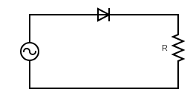

Here, the output voltage is measured across the Resistance R.

1. **Full Wave Rectifier**: Full wave rectifiers are of different types, depending on their construction. One type is the Bridge Rectifier, which uses 4 diodes and a load resistor, to rectify an AC voltage, so that the complete waveform comes out, but as a positive wave, with a little drop across the diodes, due to the cut in voltages.

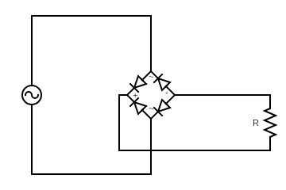

Here, the output voltage is measured across the Resistance R.

For these rectifier circuits, we define a few terms as follows:

* Average Output Voltage: It is defined as the average of the output voltage, measured across the load, over a Time Period and is given by the formula
$$V_{avg}=\frac{1}{T}*\int_{0}^{T}{V_{out} dt}$$

* RMS Load Voltage: The RMS Load Voltage is the square root of the average of the squared function of the output voltage, measures across the load, over a Time Period and is given by the formula

$V_{rms}=\sqrt{\frac{1}{T}*\int_{0}^{T}{{V_{out}}^{2} dt}}$

* Average Load Current: Also called as $I_{dc}$, it is defined as the average of the output current, measured across the load, over a Time Period and is given by the formula
$$I_{avg}=\frac{1}{T}*\int_{0}^{T}{I_{out} dt}$$

* RMS Load Current: The RMS Load Current is the square root of the average of the squared function of the output current, measures across the load, over a Time Period and is given by the formula

$I_{rms}=\sqrt{\frac{1}{T}*\int_{0}^{T}{{I_{out}}^{2} dt}}$

* Peak Inverse Voltage (PIV): The peak inverse voltage is either the maximum voltage that a diode can block, or, alternatively, the maximum voltage that a diode needs to block in a given circuit, while in the reverse bias mode.
* Ripple Factor: Ripple Factor is the ratio of rms value of AC component present in the rectified output to the average value of rectified output. It is given by the formula

$$γ=\frac{I_{ac}}{I_{dc}}=\frac{\sqrt{{I_{rms}}^{2}-{I_{dc}}^{2}}}{I_{dc}}$$

1. **Full Wave Rectifier with Filter**: This is essentially just a full wave rectifier, at whose output, a capacitor filter is attached, so that the output gets closer to the DC form, due to the charging and discharging of the capacitor.

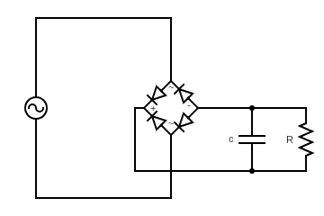

Here, the output voltage is measured across the Resistance R.

For this rectifier circuit with a filter, we define:

* Ripple Voltage: It is the residual periodic variation of the DC voltage within a power supply which has been derived from an AC source. This ripple is due to the incomplete suppression of the alternating waveform after rectification. It is given by the formula

$$V_{p-p Ripple}=V_{max}-V_{min}$$

Where $V_{max }$ and $V_{min }$ are the maximum and minimum voltages of the rectified output voltage measured at the load. Since, $V_{min}$ comes due to the discharging of the capacitor,

$$V_{p-p Ripple}=V_{max}-V_{max}*e^{-t/{RC}}$$

If we assume that the time constant of the circuit (RC) >> the time period of the waveform(T), then we can say

$$V_{p-p Ripple}=V_{max}-V_{max}*e^{-T/{2RC}}$$

Using the Taylor Expansion for $e^{x}$ and ignoring the higher order terms, we get

$$V_{p-p Ripple}=V_{max}-V_{max}\left(1-\frac{T}{2RC}\right)$$

$$V_{p-p Ripple}=V_{max}\frac{T}{2RC}$$

$$V_{p-p Ripple}=V_{max}\frac{1}{2fRC}$$

Where, f is the frequency of the waveform and equals $\frac{1}{T}$

NOTE: Since, this formula is the result of an approximation, thus an error will be present in between the theoretical and the observational values.

1. **Zener Diode Regulation**: After the previous step, we attach a Zener diode with breakdown voltage which is less than the minimum voltage of the output waveform (from the previous circuit), so that we can get a constant voltage at the load resistance.

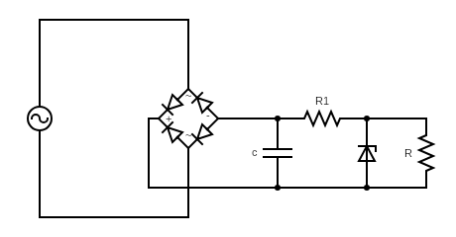

Here, the output voltage is measured across the Resistance R.

**Observations and Results:**

1. **Half Wave Rectifier**:

Simulation from VLabs.

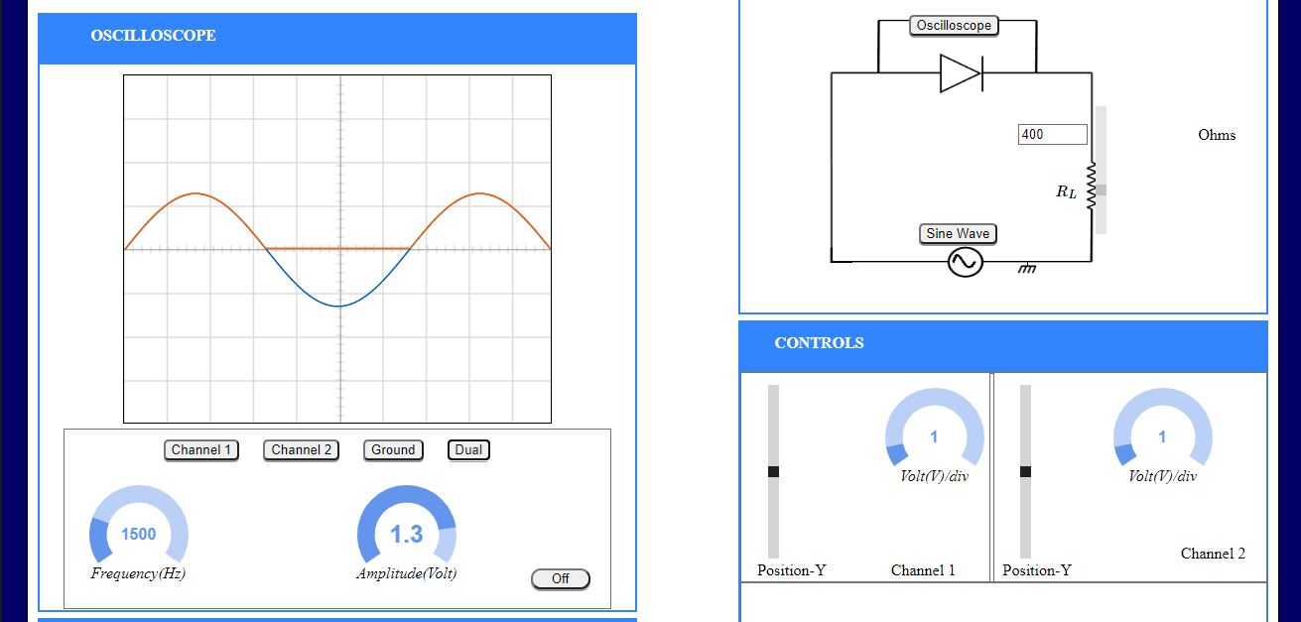

Simulation from Falstad

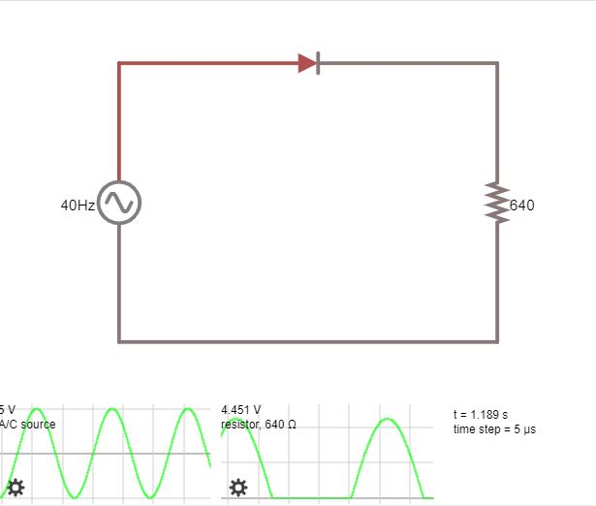

|  |  |  |  |  |  |  |  |
| --- | --- | --- | --- | --- | --- | --- | --- |
| $$V_{max, input}$$ (in V) | $$V_{max, output}$$ (in V) | $$V_{avg, output}$$ (in V) $$=(\frac{V_{max, output}}{π})$$ | $$V_{rms, output}$$ (in V) $$=(\frac{V_{max, output}}{2})$$ | $$I_{avg, output}$$ (in mA) $$=(\frac{I_{max, output}}{π})$$ | $$I_{rms, output}$$ (in mA) $$=(\frac{I_{max, output}}{2})$$ | Ripple Factor | PIV  (in V) $$=V_{max,input}$$ |
| 5 | 4.451 | 1.417 | 2.226 | 2.214 | 3.478 | 1.212 | 5 |

Here, we can observe a difference in $V_{max,input}$ and $V_{max,output}$. This is because of a drop that occurs across the diode, equal to its cut-in voltage $V_{γ}=V_{max,input}-V_{max,output}=0.549 V$

1. **Full Wave Rectifier**:

Simulation from VLabs.

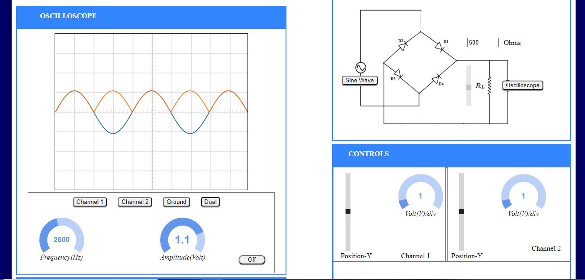

Simulation from Falstad

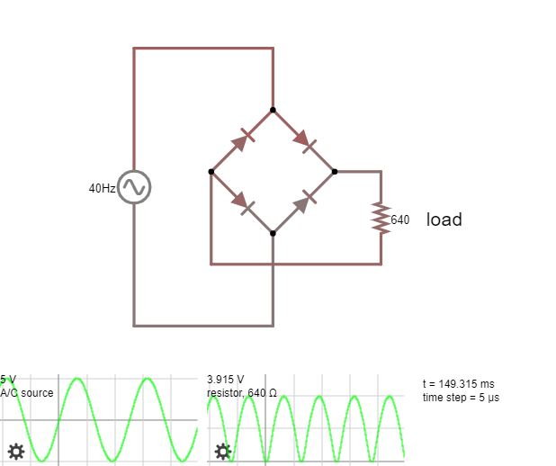

|  |  |  |  |  |  |  |  |
| --- | --- | --- | --- | --- | --- | --- | --- |
| $$V_{max, input}$$ (in V) | $$V_{max, output}$$ (in V) | $$V_{avg, output}$$ (in V) $$=(\frac{{2V}_{max, output}}{π})$$ | $$V_{rms, output}$$ (in V) $$=(\frac{V_{max, output}}{\sqrt{2}})$$ | $$I_{avg, output}$$ (in mA) $$=(\frac{{2I}_{max, output}}{π})$$ | $$I_{rms, output}$$ (in mA) $$=(\frac{I_{max, output}}{\sqrt{2}})$$ | Ripple Factor | PIV  (in V) $$=(V_{max,input}-V_{γ})$$ |
| 5 | 3.915 | 2.492 | 2.768 | 3.895 | 4.326 | 0.483 | 4.457 |

Here, we can observe a difference in $V_{max,input}$ and $V_{max,output}$. This is because of a drop that occurs across two diodes. Thus, cut-in voltages of the diodes $V_{γ}=\frac{V_{max,input}-V_{max,output}}{2}=0.543 V$

1. **Full Wave Rectifier with Filter**:

Simulation from VLabs.

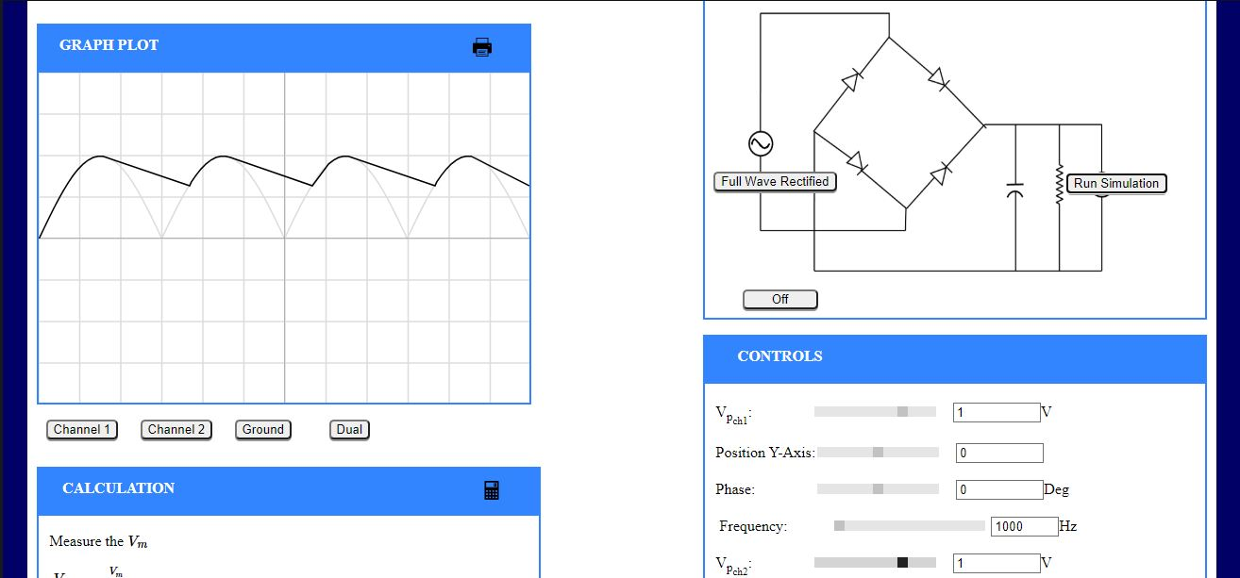

Simulation from Falstad

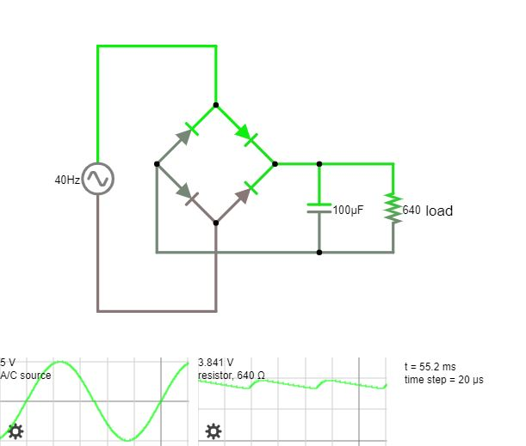

|  |  |  |  |  |
| --- | --- | --- | --- | --- |
| $$V_{max, input}$$ (in V) | $$V_{max, output}$$ (in V) | $$V_{min, output}$$ (in V) | Ripple Voltage  (in V) $$=(V_{max,input}-V_{max,output})$$ (Observed) | Ripple Voltage  (in V) $$=(V_{max,output}\frac{1}{2fRC})$$ (Theoretical) |
| 5 | 3.841 | 3.325 | 0.516 | 0.750 |

Here, we can observe a difference in $V_{max,input}$ and $V_{max,output}$. This is because of a drop that occurs across two diodes. Thus, cut-in voltages of the diodes $V_{γ}=\frac{V_{max,input}-V_{max,output}}{2}=0.578 V$.

Also, here we can see that there is a difference in the values of the Ripple Voltages calculated. This was expected, because we had used an approximation in our derivation of the formula for Ripple Voltage. Error % = $\frac{0.750-0.516}{0.750}*100\%=31.2\%$

1. **Full Wave Rectifier with Filter and Zener Diode Regulation**:

Simulation from Falstad

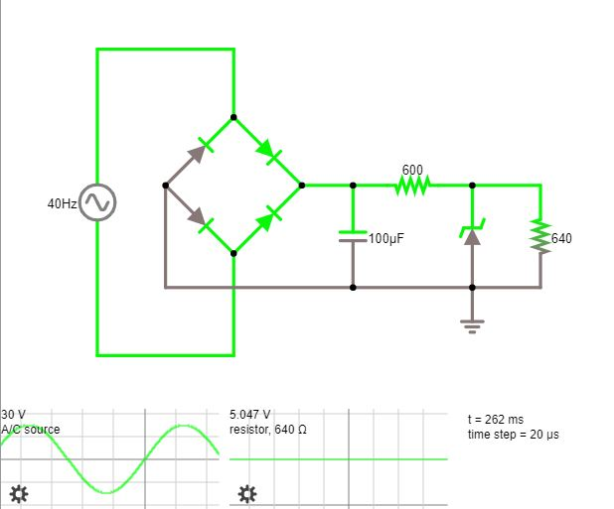

The output voltage that we now get is a DC Voltage of magnitude 5 V. This was due to the fact that we attached a Zener diode, of breakdown voltage = 5 V, to the circuit, which kept the load voltage constant and at 5 V.

**Conclusion:** After simulating the above circuits in VLabs and Falstad, we can now setup a circuit that converts an AC input to a DC output. We can also find the values for the various parameters, like the Average Voltage, RMS Voltage, Ripple Voltage etc.